Special Relativity & Magnetism

Einstein developed special relativity in an attempt to reconcile Maxwell’s theory of electromagnetism and Newton’s laws of mechanics. Einstein’s paper introducing special relativity in 1905 is actually entitled “On the Electrodynamics of Moving Bodies”.

It was known at the time that Maxwell’s theory produced asymmetries (i.e. depending on your reference frame the laws of physics appeared different). Einstein found this unsettling and proposed that the laws of physics should be valid for all frames of reference.

Einstein reconciled Maxwell’s equations and Newton’s laws of motion by eliminating the requirement of absolute space.

In so doing, Einstein showed that magnetism can be explained in terms of special relativity and electrostatics.

Let’s explore the nature of magnetism and how Einstein resolved the tension between Maxwell and Newton by looking at a simple thought experiment. Work through the questions with your group and record your answers.

**Part A: Electrostatic and Magnetic Force**

1. What is the electrostatic force? List a few examples of phenomenon due to the electrostatic force.
2. What is the magnetic force? What happens to two parallel wires with currents going in the same direction? Why?

**Part B: Alice and the Long Straight Wire**

1. Alice examines a long straight wire at rest in her reference frame. The wire is carrying a current I, but has no net charge. To see this, let’s suppose there are N positive charges per unit length and N negative charges per unit length. The charges will cancel out, leaving the wire neutral.

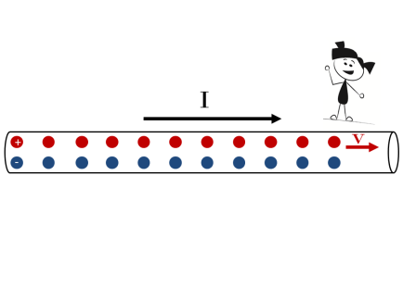

The positive charges move to the right with velocity, **v** producing a current, $I=Nev$. Despite the fact that the positive charges are moving in Alice’s frame, the charge line densities of both the negative and positive charges are the same, so the wire still remains electrically neutral. Discuss this with your group and convince yourself that this is true.

Alice knows that a current carrying wire produces a magnetic field.

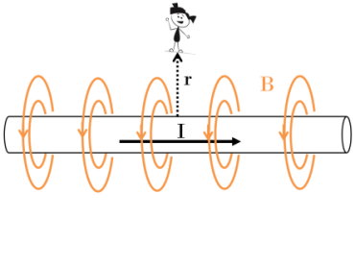

She positions herself a distance **r** from the wire and measures the strength of the magnetic field as:

$$B= \frac{μ_{o }I}{2πr}$$

where I is the current in the wire and $μ_{o }$ is the magnetic constant from Maxwell’s equations.

Alice places a small, positive charge next to her at rest.

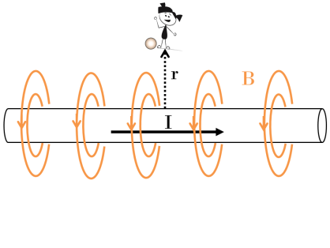

**What will happen to the charge? Will it remain at rest, move towards the wire or move away? Discuss with your group.**

1. Let’s imagine that Bob is sitting on a small, positive charge, q, at a distance **r**, from the wire. Bob is also moving at a constant velocity, **v**,relative to Alice and the wire.

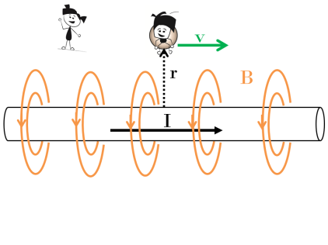

1. Alice knows that *moving* charges experience a force in the presence of a magnetic field. She watches as **Bob is deflected towards the wire**.

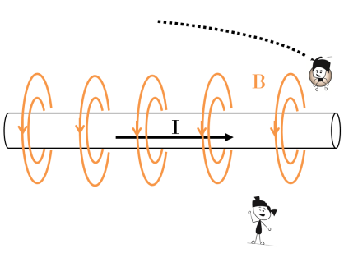

The force that deflects Bob and his charge is given by:

$$F=qvB$$

Substituting what we learned in a) we find:

$F=-qv\frac{μ_{o }I}{2πr}$

The negative sign is the convention we use to show that Bob is deflected downward toward the wire.

**Part C: Bob and the Long Straight Wire**

**a)** Consider the scene now in Bob’s rest frame.

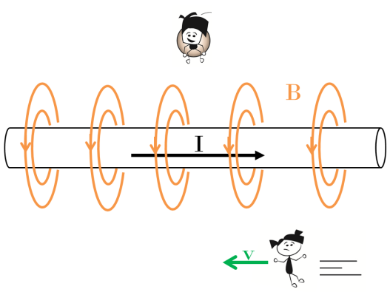

In his frame, Alice is whizzing past the wire with velocity, **v** to the left. **Given that Bob and his charge are at rest, will he experience a force due to the magnetic field of the wire?**

b) Given what you saw above do you conclude that the laws of physics depend on your reference frame? Discuss with your group.

**Part D: Einstein’s Solution**

Einstein’s Theory of Special Relativity says that the laws of physics should be the same in every reference frame. Let’s see how Einstein resolved this apparent paradox. We will examine what Alice and Bob measure for the charge line densities in the wire.

1. In Alice’s frame the negative charges in the wire are at rest. In Bob’s frame the negative charges are moving to the left with velocity **v**. Convince yourself that this is correct.

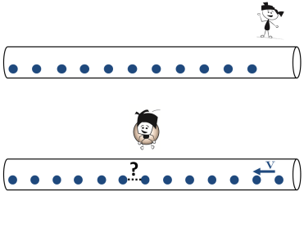

1. Based on what you know about length contraction, will the distance that Bob measures between the negative charges be bigger, smaller or the same as what Alice measures?
2. What will Bob measure for the charge per unit length for the negative charges ${N'}_{-} .$ Express your answer in terms of $γ$, where $γ=\frac{1}{\sqrt{1- {v^{2}}/{c^{2}}}}$ $,$ and N is the charge per unit length of the negative charges measured by Alice.
3. Use the binomial expansion to show that charge per unit length for the negative charges measure by Bob can be expressed as:
$${N'}_{-}=N(1+\frac{v^{2}}{2c^{2}})$$

4. In Alice’s rest frame the positive charges in the wire are moving to the right with velocity **v**. In Bob’s rest frame the positive charges are at rest. Convince yourself that this is correct.

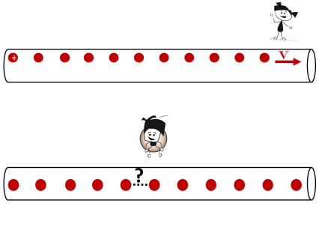

1. Based on what you know about length contraction, will the distance that Bob measures between the positive charges be bigger, smaller or the same as what Alice measures?
2. What will Bob measure for the charge per unit length for the positive charges ${N'}_{+}$? Express your answer in terms of $γ$, where $γ=\frac{1}{\sqrt{1- {v^{2}}/{c^{2}}}}$ and $N$ is the charge per unit length measured by Alice.
3. Use the binomial expansion to show that your answer in part g) can be expressed as:
$${N'}_{+}=N(1-\frac{v^{2}}{2c^{2}})$$

4. Using your expressions for the charge per unit length for the negative and positive charges in Bob’s frame, show that the charge line density measured by Bob is $λ'=-\frac{v}{c^{2}}I$. Is it positive, negative or neutral? Is this the same or different from what Alice measures?
5. Alice measured Bob’s distance from the wire as being **r**. What will Bob measure? Why?
6. Since Bob finds that the wire has a net charge density, he will also measure the wire as having an electric field. At a distance, **r**, from the wire Bob will measure the electric field as:

$$E^{'}= \frac{λ'}{2πε_{o}r}$$

Using the fact that $c=1/{\sqrt{μ_{o}ϵ_{o}}}$ show that this can be expressed as:

$$E^{'}=-v \frac{μ_{o }I}{2πr}$$

1. A charge in the presence of an electric field experiences an electrostatic force, $F=qE$. What force does Bob experience? Is this the same or different from that measured by Alice?

Alice measured a force on Bob that was purely magnetic. Bob also experienced a force, but for him it was electrostatic. Both observers agree that there is a force, but disagree on its nature. Einstein showed that electric and magnetic fields are interchangeable. Detecting one or the other depends on your reference frame. In the same way that Einstein showed that space and time are mixed into *spacetime*, he also revealed that electricity and magnetism are mixed into *electromagnetism*. The relative contribution of one or the other depends on your reference frame.

**Putting It All Together**

Review the work that you have done as a group and discuss any points that need clarification.

Summarize the concepts in your notebook. Be sure to address the following points:

- Without special relativity, why do Bob and Alice measure different forces?

- Why did Einstein think this situation was untenable?

- How does special relativity resolve the apparent asymmetry between Bob and Alice?

- What is the difference between the electrostatic and magnetic force?

- Consider the test charge that Alice placed at rest in her frame. From Bob’s perspective what will happen to that charge? Why?

**Bonus Math Challenge**

For those that know calculus, try to prove that at a distance, **r**, from a current carrying wire, the magnetic field is:

$$B= \frac{μ_{o }I}{2πr}$$

and the electric field at position **r**, due to a line of charge density $λ'$ is:

$$E^{'}= \frac{λ'}{2πε_{o}r}$$